From the Physical Therapy Department

We hope are doing well at home. We miss your children! We don’t want to overwhelm you, but we want to provide you with some fun things to do at home that can help with overall strengthening and gross motor skills.  Each week will be something different.  This week is some indoor things you can do...feel free to reach out to your PT via email with any questions!

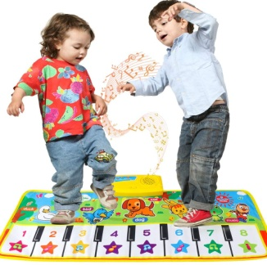 Have an [indoor dance party](https://www.understood.org/~/link.aspx?_id=B0479D51B76945D3B2B5A486295321F1&_z=z), dancing is good gross motor practice. It helps children develop balance, coordination and motor sequencing skills. It also helps build your child’s awareness of rhythm. Try using songs with lyrics that add movement, like “I’m a Little Teapot” or “The Hokey Pokey.” Animal Action song or use a piano mat like above.

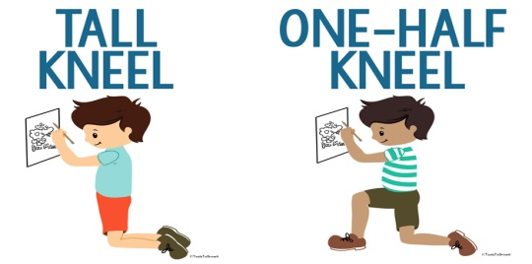

In tall kneeling, color like this- if your child likes to color. Or put stickers on a picture. If you want to add some movement do a game where they have to knee walk. Take a bean bag and knee walk (as far as they are able to do-they can go from one foot to ten feet) and put the bean bag in the bucket. Any distance is good. Or if they like: put the balls in the bucket, or the toy characters.

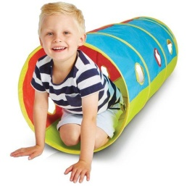Crawling during play – pretend to be a cat or a dog. If you have a tunnel at home, crawl through a tunnel. You can also make an obstacle course. You can use furniture, pillows, and blankets to create areas to crawl on, under, and through.

[](https://i.pinimg.com/originals/ea/16/9a/ea169a0663a51a4709a85e330d56cd9f.jpg) 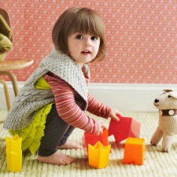

**Squatting** to pick up objects helps them to learn how to regain their balance when they’re on the move and is also great for building [**core strength**](https://theinspiredtreehouse.com/the-core-strengthening-exercise-program/).  Have them help clean up the room –this is a great gross motor activity. Squat and play with a toy…moving the cars on the pretend road in the house. Or squat down and feed the “baby” doll or the stuffed puppy dog, or build a tower with Legos or blocks.